Assignment 1: Web Development

**A Brief Description of My Webpage**

**Development**

**Submitted by: Naresh Baraili**

**Student Id: 17421481**

**Github live URL:** [**https://axcqvnz.github.io/xla_csy1018_zrc/**](https://axcqvnz.github.io/xla_csy1018_zrc/)

**Submission date:**

**Deadline: 9th April 2017 (11:59pm)**

**Contents: Pages:**

**1. Introduction 1**

**2. Wireframes 1-7**

**3. Photos 8**

**4. Problems 8**

**5. Solutions 9**

**6. Screenshots of validation 9-13**

**7. Real design 13-19**

**8. Conclusion 20**

**9. References 20**

**Introduction**

I went thoroughly into the assignment brief and set all the requirements into my mind prior I started doing my assignment. Then I started carrying out my task. At first I created a repository under github and cloned that to my local folder. Then I opened that folder in atom, a text editor, and started creating web pages. At first I just created four web pages; index.html, bio.html, cv.html and contact.html linking other three pages to index.html. After that I started creating same header and footer with same content throughout all four pages giving same styles in four different external stylesheet. Then I made different section part of different other pages with different CSS styles and added necessary texts in biography and CV page. I also included a contact in contact page. I added a favicon, a logo at upper left corner of header and two photos in the homepage and bio page respectively. I was working on github too side by side. Every time I made changes to my files, I didn’t forget to git add, git push and git commit. I also read the assignment brief time and again to check if my work was as per the requirement.

My final works were adding comments in the codes and making the webpage responsive which means how a website looks on mobile phones. Different CSS properties were included to individual CSS files so that all the pages behave accordingly in mobile phones.

It took me around 30 to 35 hours to complete the task. I have helped few of my friends with their CSS and html files. I don’t know if they credit me in their work, but I’d like to mention their names. They are Muksam Limbu (16418534), Ajay Bohara (17442641), Kishan Luitel (17439842) and Roshan Shrestha (17425086). It was not so easy for me to get the final webpage. There were many challenges which are included below under problems heading.

**Wireframes**

The task looked pretty simple but there were many smaller things to be taken into consideration while doing the whole assignment. Before giving a design to my webpage I visited many web pages but all of my favorites were using java script to design which I was not supposed to use in my design. So, I decided to create my own simple design but with all the given requirements fulfilled. Wireframes are given below:

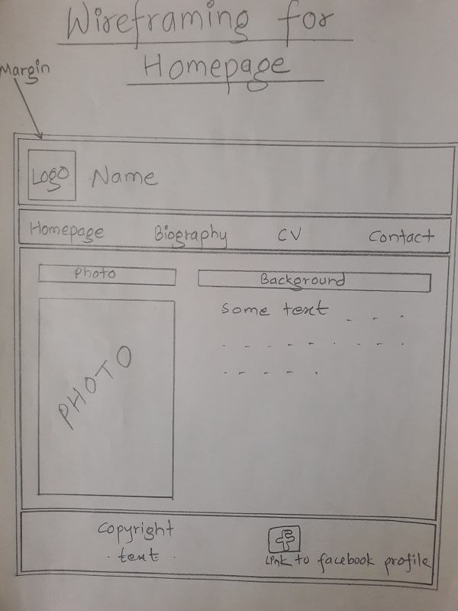

This is my wireframe for homepage.

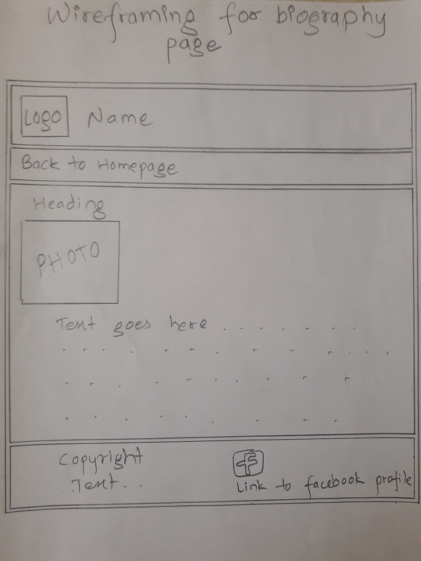

This is my wireframe for biography page.

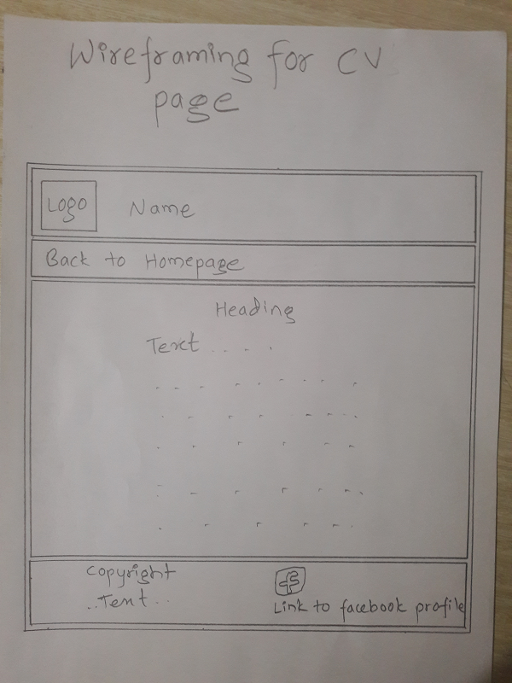

This is my wireframe for CV page.

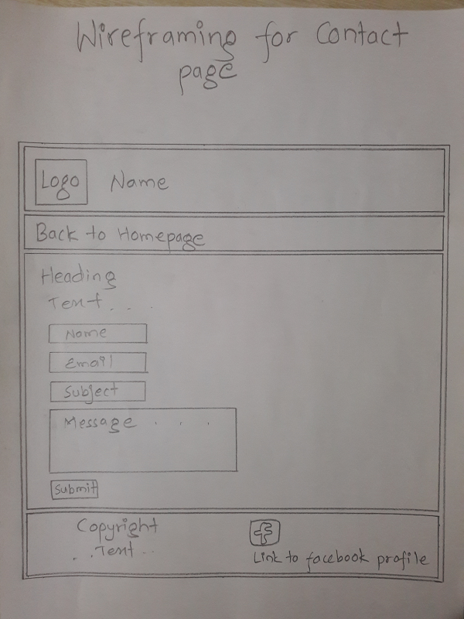

This is my wireframe for Contact page.

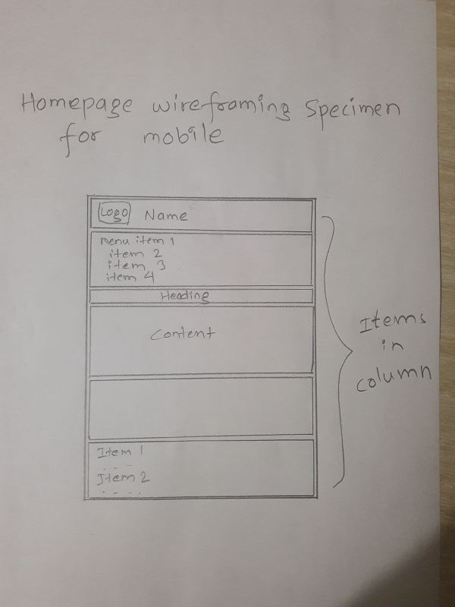

This is how the Homepage looks when viewed through mobile browser.

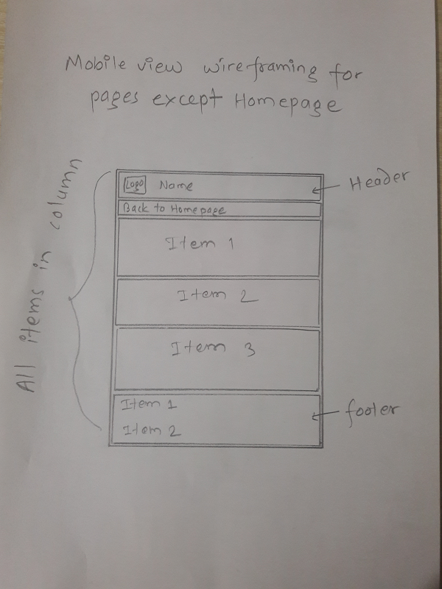

This is the wireframe specimen for bio, CV and contact page for mobile screen.

**Photos**



This photo is made in MS paint and used as favicon.



It is also created using Paint and used as a logo in the header part of every page. Clicking on it redirects to Homepage.



This photo is used to link to my facebook profile. It is created using MS word’s wordart and MS Paint. It is used in footer.

**Problems**

It had been difficult during the git commit because two three times I mistakenly pressed enter key in place of quotation resulting to incomplete git commit. Another problem I faced during the web development was maintaining margin and padding. Optimizing the images size was also a challenging task. Making pages responsive was also tough task. The final problem I had was during the markup and CSS validation. I thought I had completed my assignment and also thought it would show no error but it showed error on unordered list item and anchor tag.

**Solutions**

The problems took my few hours. However, I managed to fully solve the problems. After series of inspection through Google Chrome browser and altering values there, I managed to get the design I wanted and solved the problems related to margin and padding. I created and optimized Images on MS Paint. I was having problems in making the web pages mobile responsive but finally I noticed that viewport Meta tag was missing in between head. I also fixed the error shown on W3C markup validator and W3C CSS validator going through the line in which it showed error. However, warnings are ignored.

**Screenshots of validation**

Here are the screenshots of validation of all four webpages and four style sheets respectively.

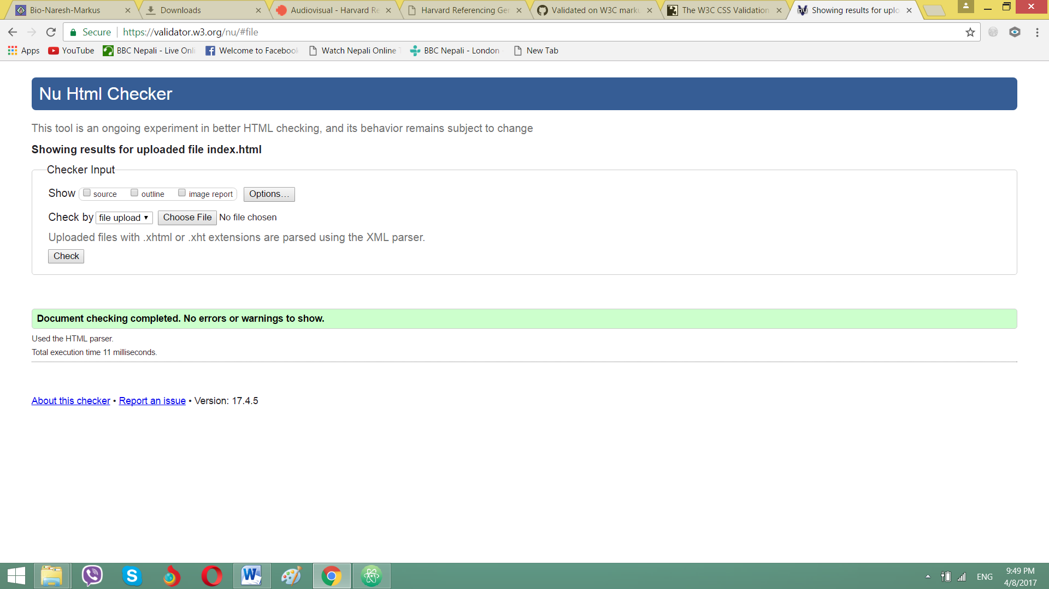

Validation of index.html

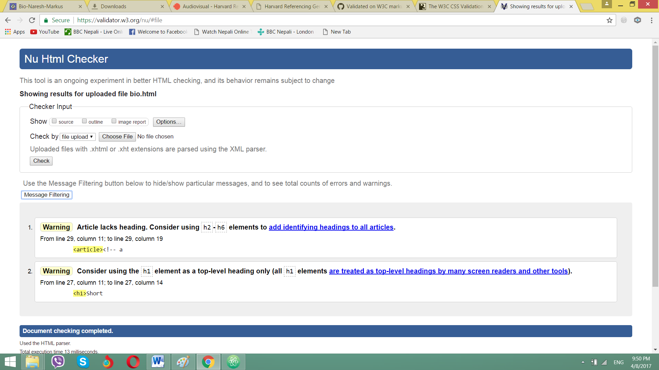

Validation of bio.html

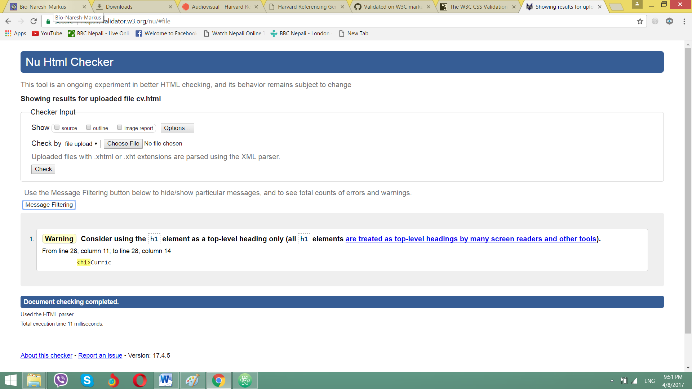

Validation screenshot of cv.html

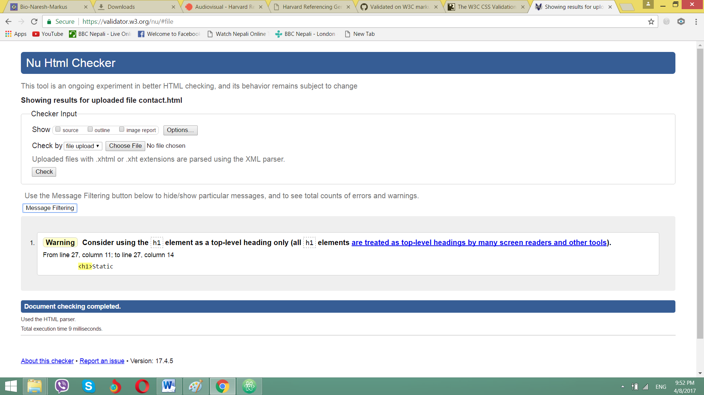

Validation of contact.html

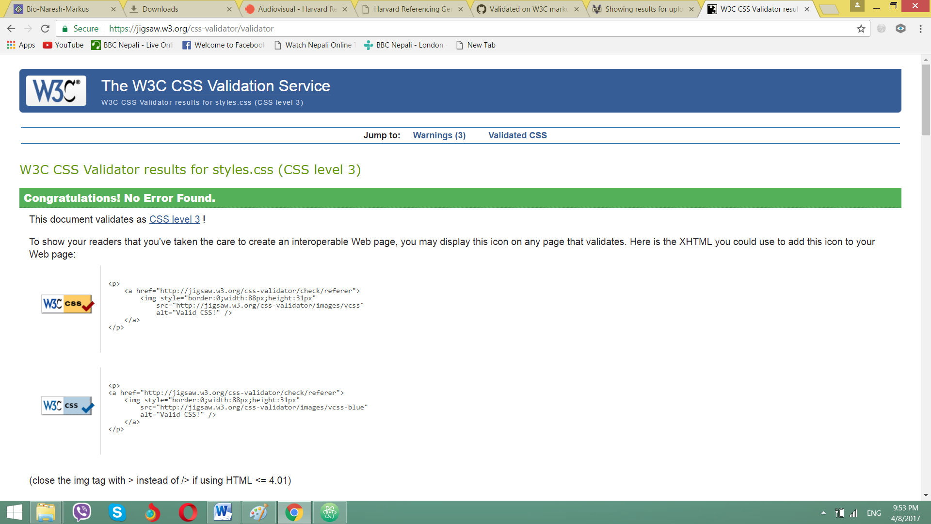

Validation of styles.css

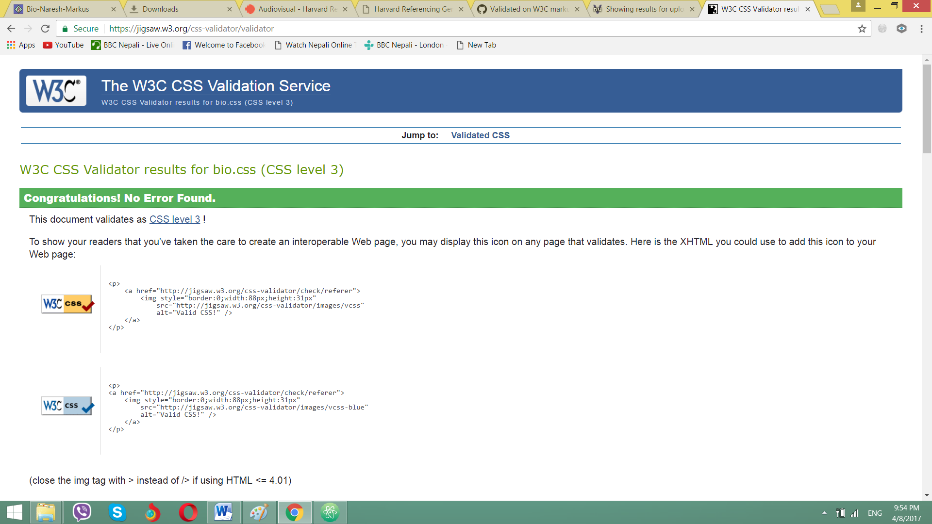

Validation of bio.css

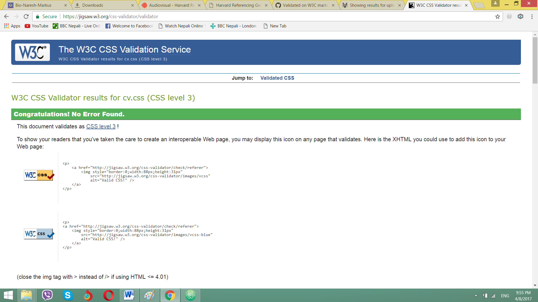

Validation of cv.css

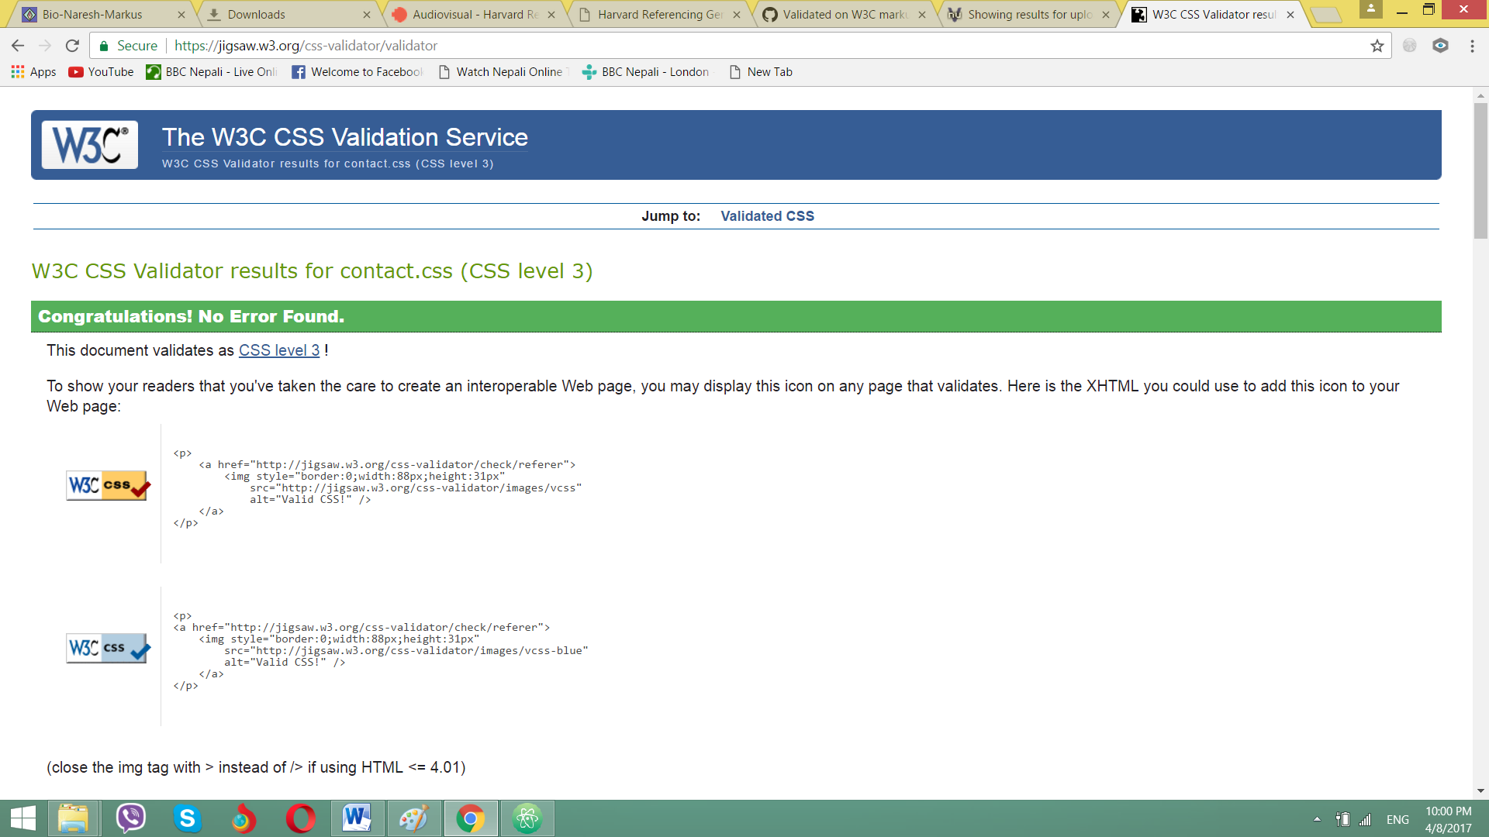

Validated contact.css

**Real Design**

Screenshots of final pages after completion are taken from laptop are shown below:

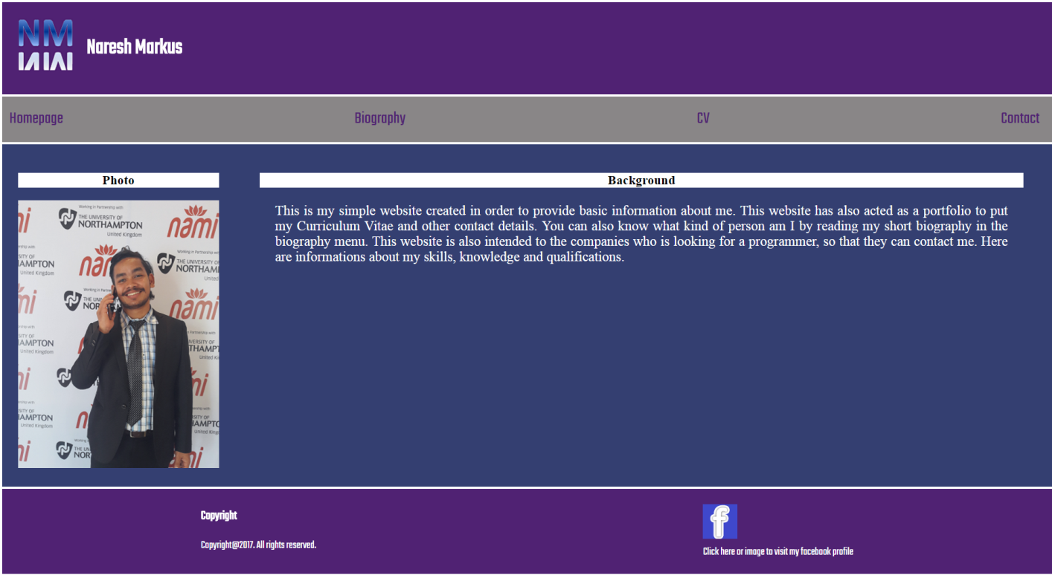

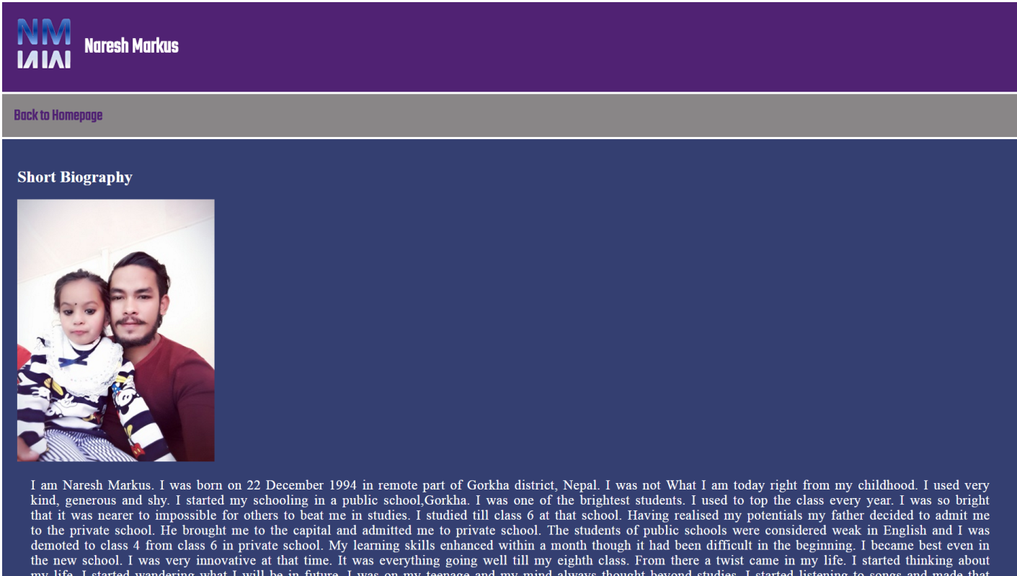

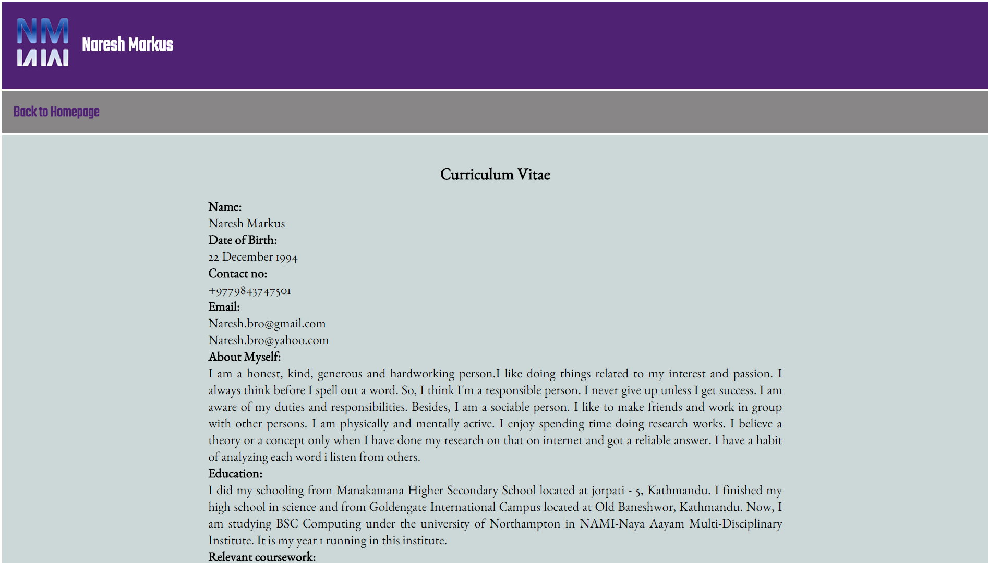

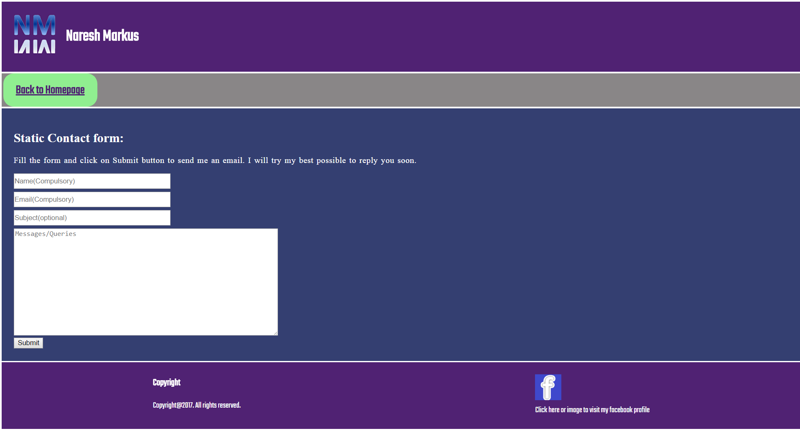

Screenshots taken from mobile phone are given below:

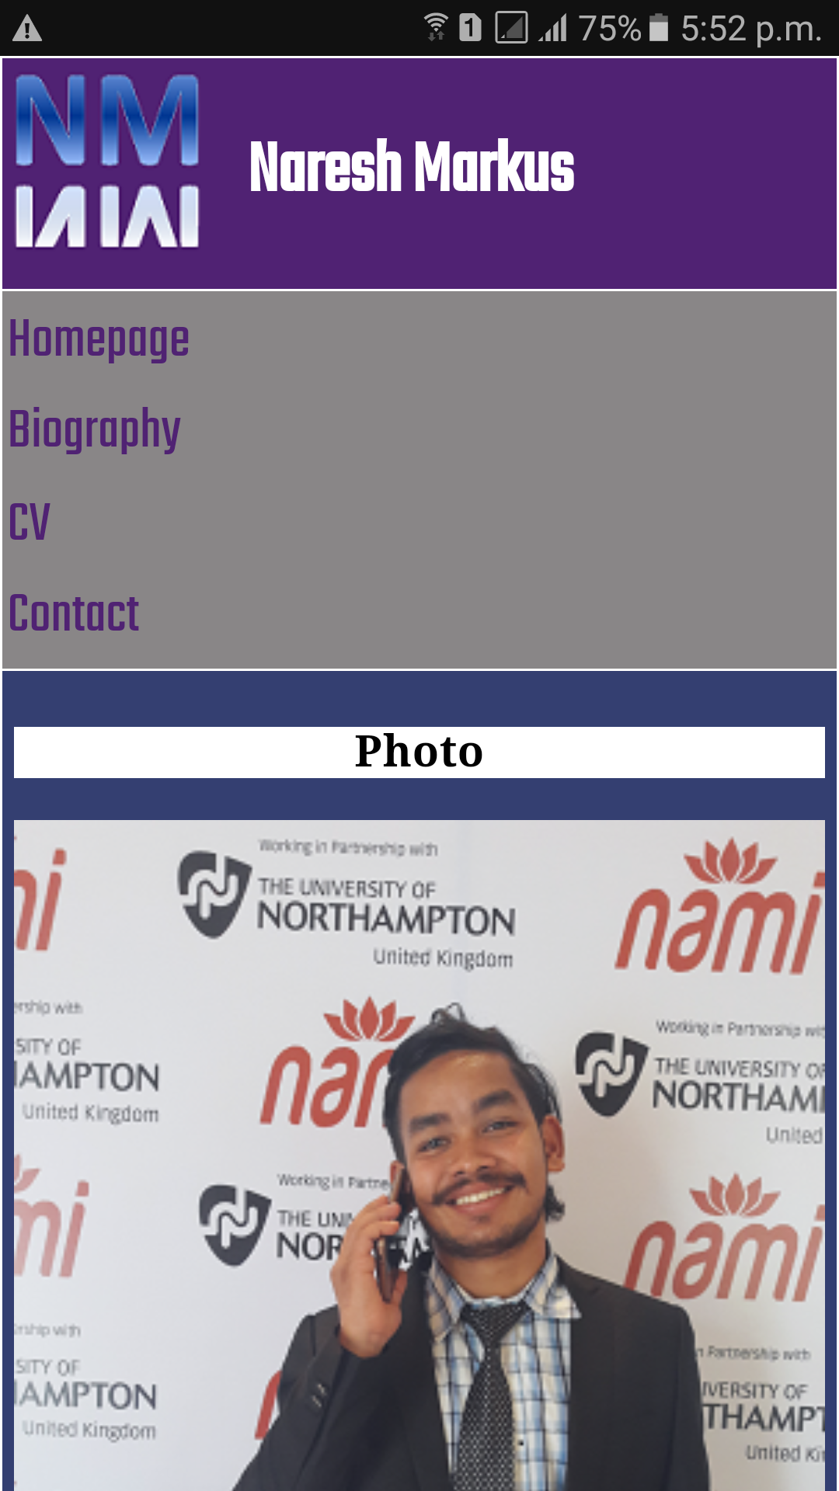

This is homepage for mobile screen.

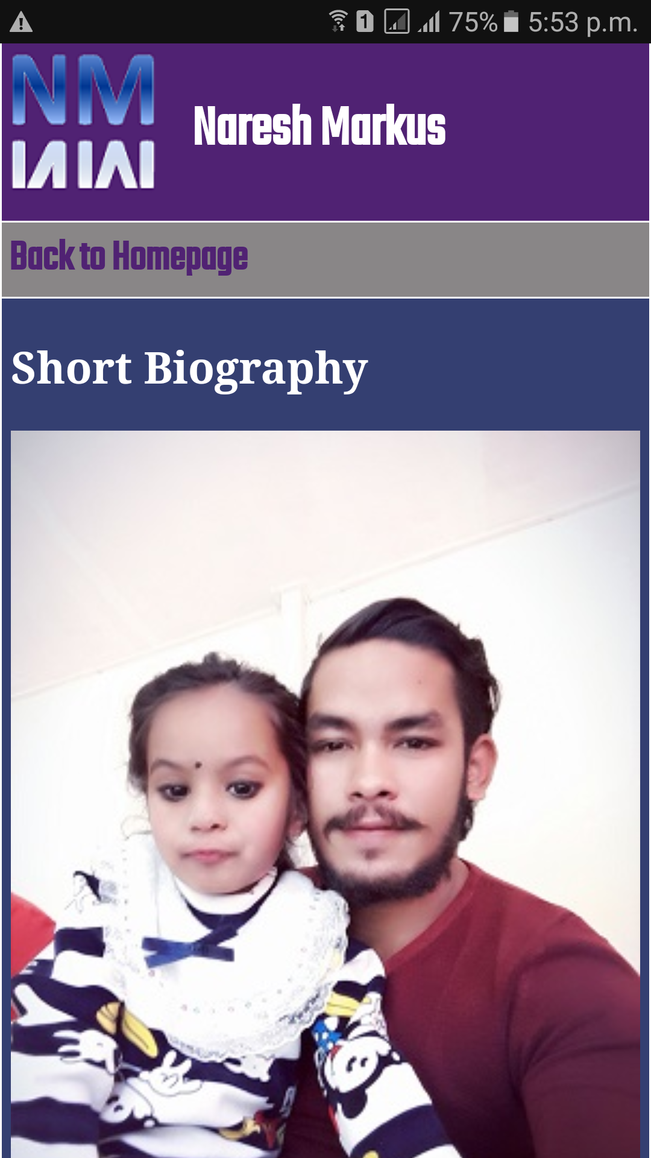

This is short biography page for mobile phones.

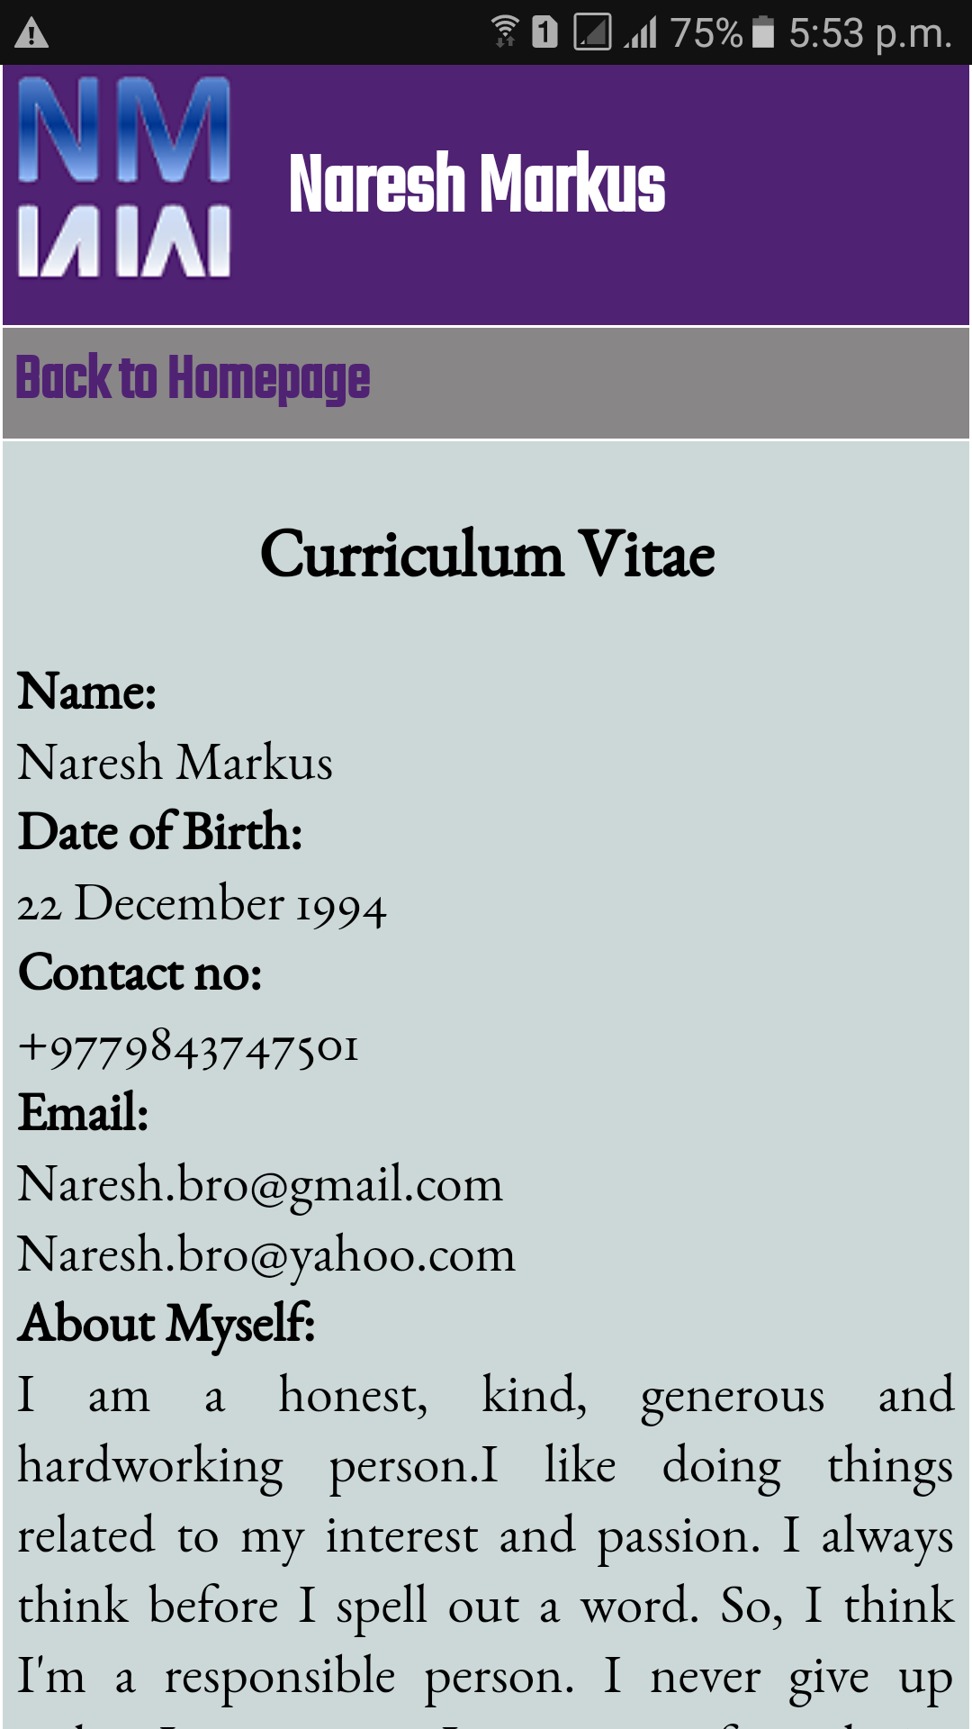

This is how CV page looks on mobile phones.

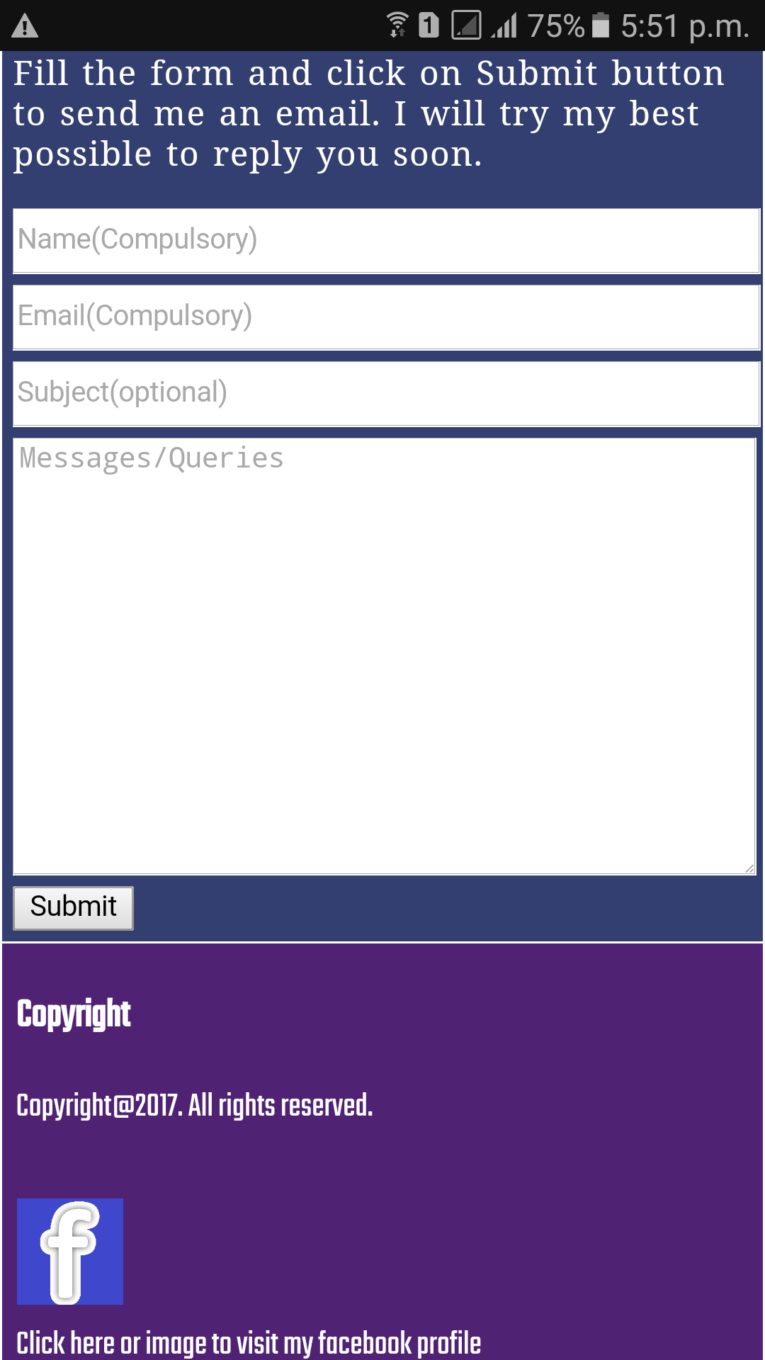

This is the mobile view of contact page with a contact form.

**Conclusion**

Finally the webpages are made as per the requirements given in assignment. A good design was made. The task made me familiar with the basic git commands such as git add, git commit and git push. The project made me compatible with the github environment.

**References**

Here are my references for the codes I’ve used in the webpages.

1. Codecourse (2014) *A Quick Guide To Using Google Webfonts*. [online]Available at: https://www.youtube.com/results?search_query=webfonts+%28codecourse%29 [Accessed 31 Mar. 2017].

2. W3schools.com. (2017). *CSS3 Transitions*. [online] Available at: https://www.w3schools.com/css/css3_3dtransforms.asp [Accessed 31 Mar. 2017].

3. W3schools.com. (2017). *CSS3 3D Transforms*. [online] Available at: https://www.w3schools.com/css/css3_3dtransforms.asp [Accessed 31 Mar. 2017].

4. Murray, M. (2017). *Elegant Contact Form*. [online] CodePen. Available at: http://codepen.io/markmurray/pen/JsAhx [Accessed 31 Mar. 2017].